Blackboard Collaborate Ultra Help Guide for Students
Every course on Blackboard has a virtual meeting space, or Course Room, through Blackboard Collaborate Ultra. Similar to Zoom, Skype, or GoToMeeting, this space can be used for synchronous communication and content sharing.

You are strongly encouraged to test Collaborate in advance to ensure that your browser works (use Mozilla Firefox or Google Chrome), you have a stable, high-speed internet connection, your microphone and audio work, and you feel comfortable with the tool and its features. Poor internet connections and slow speeds may interfere with sharing. Therefore, you should access Collaborate from a private network (e.g., at home) rather than a public one (e.g., restaurant, coffee shop). See Tips and Troubleshooting for more information.

This guide includes the following information. Click a topic to advance to that section.

Understand Collaborate Roles 2
Join Your Collaborate Ultra Course Room 3
Interact and Share 3
Audio and Video Sharing 4
Adding Your Photo 5
Content Sharing 5
Other Options 6
Leave the Course Room 7
Access Recordings (if available) 7
Join Your Course Room from a Guest Link 7
Use a Phone to Dial In 8
Before Joining 8
After Joining 8
Dialing in by Phone Only 9
Dial-In Tips 9
Join a Session (if applicable) 9
Tips and Troubleshooting 10
Tips 10
Troubleshooting 11

Understand Collaborate Roles
Before entering Blackboard Collaborate, it is important to understand the different attendee roles. Collaborate rooms have three primary roles: Moderator, Presenter, and Participant. Captioner is another role but used less often.

- Moderator: Instructors will enter the room as Moderator by default. This role has no restrictions and has full control over the room’s settings and features. Moderators can do the following:
  - Change others’ roles
  - Change room settings
  - Grant permissions to or remove attendees
  - Record sessions
  - Create and manage polls
  - Set a timer
  - Split up attendees into breakout groups and move among them
  - Share primary content (a blank whiteboard, applications/screens, and files)
  - Use the chat and receive messages sent to Moderator only
  - Raise and lower your hand
    - Lower others’ hands
  - Share audio and video
  - Draw on whiteboard and files
  - Receive and change settings for various sound and pop-up notifications
- Presenter: Unless this role is specifically designated to attendees (those enrolled in the course) or guests (those sent the guest link) in the room set-up options, nobody will enter in this role by default. However, the Moderator can change anyone’s role to Presenter, which is most appropriate for attendee presentations. Presenters can do the following:
  - Share primary content (a blank whiteboard, applications/screens, and files)
  - Use the chat
  - Raise and lower your hand
  - Share audio and video
  - Draw on whiteboard and files
  - Receive and change settings for various sound and pop-up notifications
- Participant: By default, guests and students will be designated a Participant. This role is the most restrictive (unless the Moderator changes the settings) but can do the following by default:
  - Use the chat
  - Raise and lower your hand
  - Share audio and video
  - Draw on whiteboard and files
  - Receive and change settings for various sound and pop-up notifications

Join Your Collaborate Ultra Course Room
Look for the Blackboard Collaborate Ultra link and icon in your course to join and engage in a live, remote meeting. Your instructor may also share instructions for accessing the Course Room.

If you do not see a Blackboard Collaborate Ultra link in your course, you can access it by clicking on Tools in the left menu. If you are using the Blackboard app on a mobile device, Collaborate appears in your course’s menu, and clicking on it will take you directly into the Course Room.

- To enter your Course Room, click on the Blackboard Collaborate Ultra link in your course or click on Tools in the left menu.
- Your Course Room will appear near the top. Click on it.
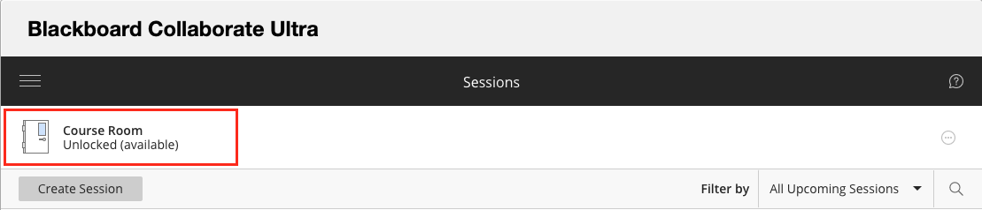
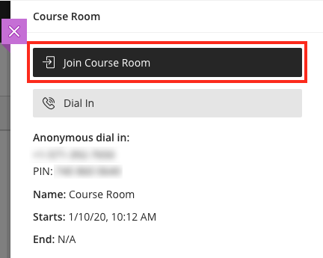
- In the panel that opens on the right, click Join Course Room.
- Upon entry, you may be prompted to allow and check your microphone and camera settings, especially if this is your first time using Collaborate. It is a good idea to test them out in advance.
  - If you are not prompted, you can manually check your settings once you join the room.
    - Click on the Open Collaborate panel button (a purple tab with arrows in the lower-right).
    - Click on the Settings (gear icon) in the panel menu.
    - Click on Audio and Video Settings to expand the options.
    - Then click Set up your camera and microphone and follow the prompts.

Interact and Share
Once you have joined a session, you will need to see what your instructor has enabled you to share and then determine what you want to or can share. By default, nothing will be turned on when you join the session aside from showing you have entered. However, if your instructor has enabled features, you will have many options for interacting and sharing items.
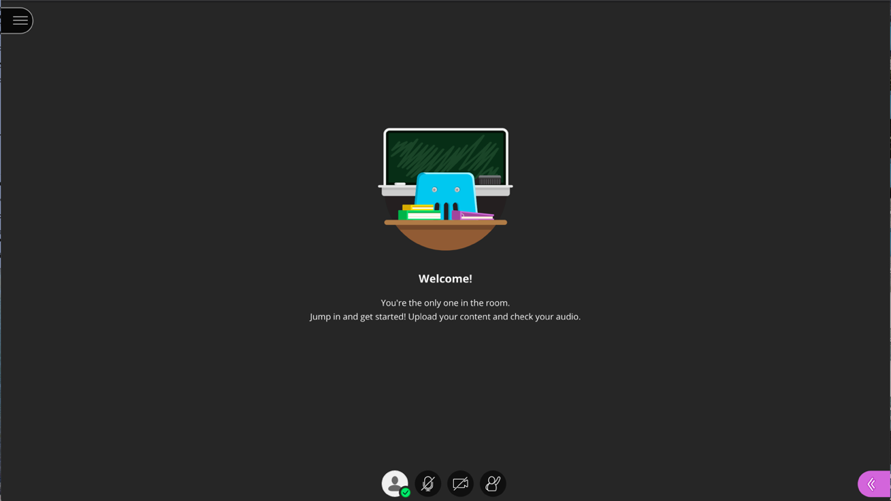

Audio and Video Sharing
The first set of options appears in a menu of icons along the bottom of the screen: audio and video sharing and hand raising.

- Click the icon of the feature you wish to turn on. Click again to turn off the feature.
  - The microphone icon will share your audio.
  - The camera icon will share your video.
  - The raised hand icon allows you (and other students) to show when you have something to say without interrupting the speaker. Your instructor may also ask you to raise your hand in other instances.
    - As participants raise their hands, they are added to a queue, and the instructor can call on them to share their thoughts, just as they would in class.
    - You can lower your hand by clicking the icon again, or the instructor can remove you from the queue.
    - You can also ask questions or add comments by using the chat feature (as long as it’s enabled) either instead of or in addition to raising your hand.
- When icons are black and white and have a slash going through them, they are turned OFF.
- The icons will appear in color with no slashes when they are ON. 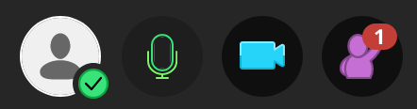

Adding Your Photo
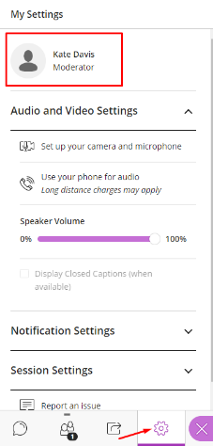
You can add a default profile photo in Collaborate, which will show up in the Attendees list and also display whenever you are not sharing your webcam. This helps participants put a face with your name and provide a way of seeing the speaker when webcam sharing may lead to connection issues.

- To add your photo, enter any Blackboard Collaborate Ultra Course Room.
- Expand the side panel inside of the room by clicking on the purple tab in the lower-right corner.
- From the bottom menu in the panel, click on the gear icon to access your My Settings.
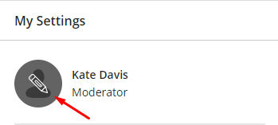
- At the top of the My Settings menu, you will see your name and an icon with the outline of a person.
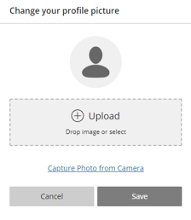
- Hover over the person icon and a pencil will appear.
- Click on the pencil.
- You will be taken to a menu where you can upload a profile picture.
- Either click on the plus sign (+) or drag a file to the Upload box.
- You may be prompted to crop or adjust your image.
- Click Save when finished.

Content Sharing
Collaborate enables your instructor to share content, making the session more dynamic. Most of the time, you will enter a Course Room in the role of Participant, and the instructor will be the Moderator. The instructor can change your role from Participant to Presenter, which would increase your content sharing options. Be aware that poor internet connections and slow speeds may interfere with sharing. Therefore, you should be on a private network (e.g., at home) rather than a public one (e.g., public place, such as a school, restaurant, coffee shop).

Note: If you do not see these options in your panel, the instructor has not enabled them for you.

- To access Content Sharing, click on the Open Collaborate panel button, which looks like a purple tab with arrows in the lower-right corner of the window.
- The panel will open the chat feature by default, but you can toggle back and forth between the menu options by clicking on the icons at the bottom of the panel.
- To share content, click on the third icon in the panel, an arrow with a box around it.
- Choose what you want to share and then select the item or content and click Share Now.
  - Share Blank Whiteboard: Use to draw or illustrate concepts or lessons.
  - Share Application/Screen:
    - Select Just an Application to filter out anything on your screen except the application - use for sharing documents that you will edit live or how-to demonstrations requiring just one application.
      - You must have the file open and not minimized to share it.
    - Select Screen to share your entire screen - use to edit multiple files live or provide demonstrations that involve switching back and forth between applications.
      - When you share your entire screen, it will look as if two mirrors are facing one another, infinitely repeating. That is normal. Proceed to the application you want to use, and that will display to participants in place of the mirrors. Essentially, what you see on your screen once you share it is exactly what participants will see.
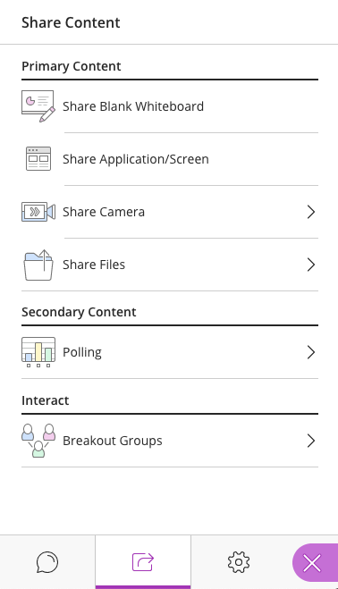
    - Note: To share an application/screen, you must be using Google Chrome or Mozilla Firefox.
  - Share Camera: Use to share a secondary camera, such as a doc cam or external webcam. There is no limit on the number of cameras shared.
Note: The camera must be plugged in prior to joining Collaborate, or it will not be recognized as an option to select.
  - Share Files: Use to share static image, PowerPoint, or PDF files that do not require live editing (allow time to upload) and have no transitions or animations.
    - Although you cannot edit the file itself, you can draw and type on it, as this feature comes equipped with the same toolbar available in the Blank Whiteboard sharing option.
- Although you can only share one view at a time, you can switch as needed throughout.

Other Options
The Collaborate panel also contains other options.

- Click on the first icon in the panel, a chat bubble, to reveal the chat feature.
  - This is useful for participants who do not have or cannot currently use audio or video or when they want to add a comment but do not want to interrupt.
- To view a list of attendees and their roles, click on the second icon, an outline of two people.
  - From this menu, the moderator can change participants’ roles, see participants’ internet connection strength, see whose audio is on, mute participants, and remove participants.
- The fourth icon, a gear, allows you to check and change settings related to audio and video, notifications, and [when you are the moderator] participant permissions for sharing, chatting, and writing.
- If, at any point, you would like to close the panel and return to the full screen, click on the Close Collaborate Panel, which looks like a purple tab with an X and appears in the lower-right corner of the window.

Leave the Course Room
When your session has come to an end, you can close your tab/window or click on the Session Menu button (three lines in the upper-left corner) to expand it and then click Leave Session.

Note: If your instructor created a session with an End, it will abruptly end at that time.

Access Recordings (if available)
Your instructor may record sessions that take place in Collaborate. If so, you can access and watch them later.

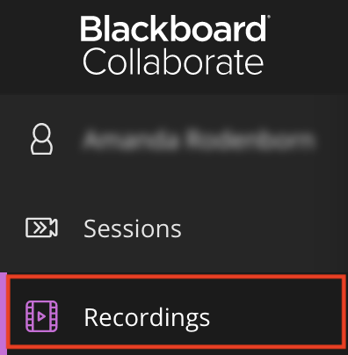
- To access any of the course's recorded sessions, click on the Blackboard Collaborate Ultra link, the same way you would access the Course Room.
- Open the menu by clicking on the three lines in the upper-left.
- Click Recordings.
- A list of all recorded sessions will appear.
  - Click on the title of any session and select Watch Now to view the recording.
    - You may need to adjust the filter in the upper-right to access older recordings.
  - You can return to the list of sessions by revisiting the same menu and clicking back to Sessions.

Join Your Course Room from a Guest Link
By default, guests are not allowed to join a Collaborate Course Room, as this poses a security risk. However, there are instances where your instructor may share out a guest link with you. The guest link allows a one-click entry, so it is convenient.

- If your default browser is Chrome or Firefox, click on the guest link, enter your name, and join the Room.
- If your default browser is not Chrome or Firefox or if the URL is not hyperlinked, copy and paste it into the search bar of Chrome or Firefox and click enter. Type in your name and join the Room.

Use a Phone to Dial In
There are a number of ways for users to dial in to a Collaborate meeting, using a phone for audio. This is useful if you are having audio problems or do not have a microphone or speakers.

Notes: No more than 25 attendees can dial in to a meeting at a time. If a number does not appear, the calls have reached capacity. Also, if you are using the Blackboard app to join a room, the dial in and app audio cannot be used simultaneously.

Before Joining
- Click on the Course Room to open a panel on the right.
- Beneath the Join Course Room button, you will see the Anonymous dial in number along with a PIN.
  - If you are using a web browser on a mobile device to access the room, click on the Dial in button and enter the PIN when prompted.
    - iPhone users: the PIN is automatically entered.
    - Non-iPhone users: write down the PIN beforehand.
  - If you are using a computer to access the room, use your phone to call the number displayed and enter the PIN when prompted.
  - You can still join the course room to follow along on screen, use all of the tools, and share your video.
- Note: When users follow these steps to dial in, the PIN is not associated with their personal account, so they will be identified as an anonymous caller with only the last four digits of their phone number displayed. PINs are unique to rooms and sessions and will no longer work if there is an end time.

After Joining
- Once inside the room, click on the three lines in the upper-left corner to expand the menu.
- Select Use your phone for audio, which will display a dial-in number and PIN.
  - If you are using a web browser on a mobile device to access the room, click on the number and enter the temporary PIN when prompted.
    - iPhone users: the PIN is automatically entered.
    - Non-iPhone users: write down the PIN beforehand.
  - If you are using a computer to access the room, use your phone to call the number displayed and enter the temporary PIN when prompted.
  - You can remain in the meeting space to follow along on screen, use all of the tools, and share your video.
- Note: When users follow these steps to dial in, the PIN is associated with their personal account, so they will be identified as their name appears on the roster. This PIN is unique to users and should not be shared. PINs are unique to rooms and sessions and will no longer work if there is an end time.

Dialing in by Phone Only
- If an anonymous dial-in number and PIN have been provided to you in advance, you can still call in to the meeting and use your phone for audio even if you do not have the Blackboard app, the appropriate web browser, or an internet connection.
  - Dial the number provided and enter the PIN when prompted.
  - Naturally, you will be identified in the meeting as an anonymous caller.
  - You will not be able to join the Course Room and therefore will not be able to follow along on screen, use any of the tools, or share your video.

Dial-In Tips
- When you join the room via dial in, you will be sharing audio by default.
- If you are connected to the room by your phone only, use *6 to mute and unmute your phone.
- If the moderator has muted you, use *6 to unmute when directed.
- If you are also connected to the Collaborate room on an additional device so you can view the screen, you can press Alt+M on your keyboard to turn your phone audio on or off as needed throughout the meeting.

Join a Session (if applicable)
Instead of joining your Course Room, your instructor may decide to create a separate session for each meeting time.

- When you're ready to begin your class session, click on the Blackboard Collaborate Ultra link in your course or by going to Tools in the left menu.
- If your instructor has set up specific sessions with start dates and times, you will see them listed below the Course Room.
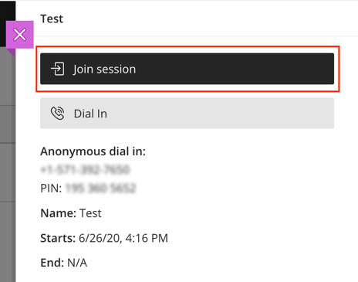
  - Your instructor may have set up recurring sessions. If so, it may look as though there is only one session, but it will say “Recurring,” followed by dates underneath the title. Click on this title to expand the full list of sessions.
- Find the specific date and time of the session you want to join and click on it.
  - If your instructor set up an Early Entry time (the default is 15 minutes before), you will not be able to access the session before then.
- After clicking on the session title, a menu will open on the right, where you will click Join session.
- Once you join, you may be prompted to allow and check your microphone and camera settings, especially if this is your first time using Collaborate. It is a good idea to test them out in advance in case your instructor wants to use them.
  - If you are not prompted, you can manually check your settings once you join the session.
    - Click on the Open Collaborate panel button (a purple tab with arrows in the lower-right).
    - Click on the Settings (gear icon) in the panel menu.
    - Click on Audio and Video Settings to expand the options.
    - Then click Set up your camera and microphone and follow the prompts.
  - These checks may also arise as you turn on microphone and camera features (see Audio and Video Sharing).

Tips and Troubleshooting
If you experience issues while using Blackboard Collaborate Ultra, try the following.

Tips
- Make sure you are using the most recent version of Google Chrome or Mozilla Firefox.
  - See Preparing for Your First Blackboard Collaborate Ultra Session to see if your version of Chrome or Firefox is up to date and learn other tips.
  - View Blackboard’s set of Best Practices for using Collaborate.
  - Mobile users: See Browser and Operating System Support to see if your device and browser are supported.
    - Suggested browsers for mobile are Chrome (Android) or Safari (iOS).
    - All features may not be available on mobile.
    - You may need to adjust application settings in your phone, allowing the browser to play audio and use your camera.
- Join your Collaborate room early to establish a connection and make sure everything is working properly to avoid last-minute rushing.
- If available, use a hard-wired (Ethernet) connection.
- Avoid burdening your internet connection.
  - See Network Connection Management, which includes information on how different features in Collaborate might affect your experience.
  - Close other browser windows and tabs as well as unused applications.
  - Share only what you need, when you need it.
    - Limit webcam video and entire screen sharing.
    - Share files or the whiteboard, instead of application/screen, whenever possible.
    - Do not share your webcam when you are sharing other content.
    - Avoid showing videos during a lesson. Instead, share the link to the video in the chat area, having participants leave the session and return after viewing it.
  - When possible, make sure others who share your internet connection are not streaming audio/video, web conferencing, gaming over the internet, uploading/downloading large or a lot of content, etc.

Troubleshooting
- Leave the session/room and return to reconnect.
- Make sure your internet provider or wi-fi connection is not experiencing an outage.
- Attempt basic troubleshooting.
  - Wait a few minutes and refresh the page.
  - Clear your browser cache: Google Chrome cache or Mozilla Firefox cache.
  - Close your browser completely.
  - Restart your computer.
  - Restart your router.
- Check your audio and video quality.
  - See Troubleshooting Audio/Video Quality Issues.
  - See Participant Audio and Video Troubleshooting for Chrome.
  - See Participant Audio and Video Troubleshooting for Firefox.
- Check the Blackboard Services Status page to see if there is a Blackboard or Collaborate outage.
  - Click on the + next to Americas and find Collaborate Ultra – AWS (US) to view status for each day.
- Seek assistance.
  - Contact DMACC Tech Support immediately. Student workers have a Collaborate room dedicated to helping students resolve problems.
- Last resort: If the problem is extensive and persists, you may need to upgrade your internet service.
  - Run a speed test. See Network Connection Management to know what speeds you will need based on the features in use.
    - Gauge: Those with an average upload speed of 15 Mbps and a download speed of 60+ Mbps have rarely experienced issues.

